**Thruster Report**

|  |  |
| --- | --- |
| **Thruster Ratio:** | **1.200** |
| **Magnetic Field:** | **750 mT** |
| **Anode Power:** | **2248 W** |
| **Anode Current:** | **6.0 A** |
| **Anode Energy:** | **137120.7 J** |
| **Propellant:** | **Argon 0.499 mg/s** |

**Thruster Details: Nagoya magnet, LaB6 cathode, 1 mm orifice, copper anode, 80 mm internal diameter. CoM correction method: Anode Energy, Pre-offset 0.0 s, Post-offset 100.0 s, Cold-Gas thrust 0.1 mN**

|  |  |  |  |  |  |  |
| --- | --- | --- | --- | --- | --- | --- |
| Thrust | Thrust Eff. | ISP | Total DOF | Coverage Factor | Exp. Uncertainty | Std. Uncertainty |
| 23.9 mN | 25.4 % | 4877.0 sec | 12 | 2.12 | 5.6 mN | 2.6 mN |

**Thrust-Stand Uncertainty Components**

|  |  |  |  |  |  |  |  |
| --- | --- | --- | --- | --- | --- | --- | --- |
|  | Weights | Scale | Hysteresis | Repeatability | Noise | Offset | Drift |
| Value | 0.0 mN | 0.9 mN | 0.7 mN | 0.3 mN | 0.8 mN | 1.1 mN | 1.9 mN |
| DOF | 30 | 6 | 6 | 6 | 31 | 4 | 4 |

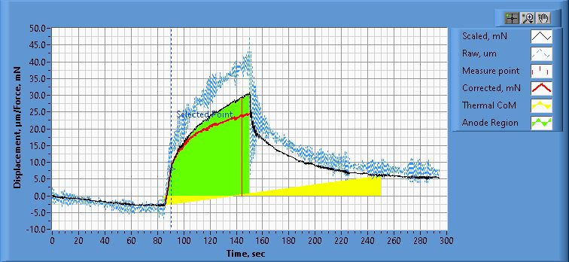

**Figure 1. Thrust Plot**

File Name: Philtech Data 2025.04.15_23.54.28.csv

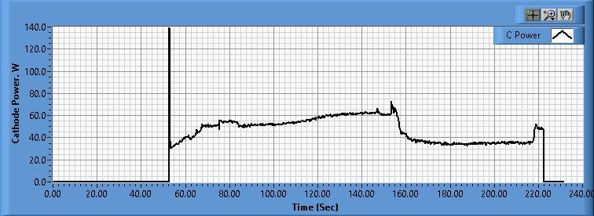

**Figure 2. Cathode Power Plot**

File Name: PSU C Data 2025.04.15_23.53.20.csv

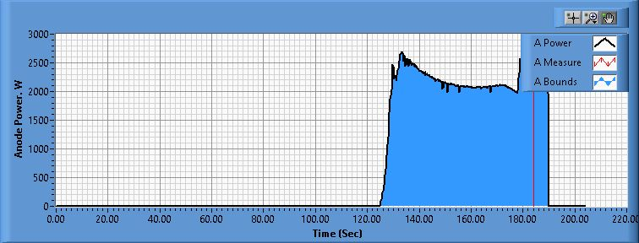

**Figure 3. Anode Power Plot**

File Name: PSU A Data 2025.04.15_23.53.48.csv

**Pre-Cal. Information**

File Name: Philtech Data 2025.04.15_16.30.51.csv

Start/Stop times (24 h): 16:30:58 16:32:53

Sensitivity: 1.58 um/mN

|  |  |  |  |
| --- | --- | --- | --- |
| Offset | Drift | Scale Factor | Scale Std.Dev |
| -0.981 mN | -0.062 mN/s | 0.633 | 1.318 mN |

Plateau values:

|  |  |  |  |  |  |  |  |  |  |  |
| --- | --- | --- | --- | --- | --- | --- | --- | --- | --- | --- |
| Weight 0 | Weight 1 | Weight 2 | Weight 3 | Weight 4 | Weight 5 | Weight 4 | Weight 3 | Weight 2 | Weight 1 | Weight 0 |
| -1.1 mN | 20.8 mN | 38.3 mN | 59.0 mN | 78.5 mN | 100.8 mN | 79.2 mN | 59.4 mN | 39.5 mN | 21.9 mN | 0.9 mN |

**Post-Cal. Information**

File Name: Philtech Data 2025.04.15_23.54.28.csv

Start/Stop times (24 h): 23:59:40 00:01:40

Sensitivity: 1.54 um/mN

|  |  |  |  |
| --- | --- | --- | --- |
| Offset | Drift | Scale Factor | Scale Std.Dev |
| -6.278 mN | -0.020 mN/s | 0.650 | 1.159 mN |

Plateau values:

|  |  |  |  |  |  |  |  |  |  |  |
| --- | --- | --- | --- | --- | --- | --- | --- | --- | --- | --- |
| Weight 0 | Weight 1 | Weight 2 | Weight 3 | Weight 4 | Weight 5 | Weight 4 | Weight 3 | Weight 2 | Weight 1 | Weight 0 |
| -0.9 mN | 20.5 mN | 37.9 mN | 58.4 mN | 78.9 mN | 101.1 mN | 78.5 mN | 58.4 mN | 38.0 mN | 20.6 mN | -1.7 mN |